LABORATORY WORK **№ 2**

SERIES AND PARALLEL CONNECTION OF SOLAR PANELS

The purpose of the work: to study the possibility of working in series and parallel connection and to determine the current-voltage characteristics of solar cells.

Program of work  
1. Study of the method of connecting solar cells.  
2. Carrying out an experiment with a serial connection of solar converters.  
3. Carrying out the experiment with a parallel connection of solar cells.  
4. Comparative analysis of connection methods and conclusions on the results of laboratory work  
5. Report writing

**Short theory**

Photovoltaic panels are often connected to serial-parallel connections, thus increasing the output power.  
In the event that several solar cells (or parallel connections of several photocells) are combined in a chain consecutively, then their initial voltage is significantly increased. When the solar cells (SE) are connected in series, all the elements are connected by a chain and combined with adjacent opposite poles (Figure 1). For example, in order to obtain a ready-made voltage of 220 V at the output, it is enough to connect ten solar panels in parallel with an output voltage of 24 V or 20 - with voltages of 12 V.  
But this connection has a number of shortcomings:  
1) non-constant value of voltage under conditions of poor illumination;  
2) weak power of the whole system, which is equivalent to the power of one battery.

+

+

+

+

+

+

̶

̶

̶

̶

̶

̶

**CЭ**

**CЭ**

**CЭ**

**CЭ**

**CЭ**

**CЭ**

Fig. 1. Series connection of solar converters

If a series of solar panels (or successive connections of several photovoltaic panels) are connected in parallel, in this case the maximum current strength of the entire panel of panels is equivalent to the product of the maximum achievable force of one panel or a combination thereof by the number of panels or their composition. In the ideal case, the maximum power of a serial and parallel connection of identical panels is equal to the product of the maximum power of each panel by the number of panels. In other words, the maximum power (Pmax) of such a compound is equal to the product of Vvoy and Imax of the whole composition.  
In fact, the power of the thus achieved solar panel will be less than the power of the total sum of the powers of the components its parts by the magnitude of the loss is not an agreement; The losses caused by the difference in characteristics of the same type of modules. To do this, it is important to carefully select the modules in the solar panel to minimize the loss of power for the mismatch. With parallel connection, all panels are connected in parallel with the same poles (Figure 2). Although such connections require the use of an additional voltage converter, they will achieve significant electrical power and constant operation.

+

+

+

̶

**CЭ**

**CЭ**

**CЭ**

**CЭ**

**CЭ**

**CЭ**

+

+

+

+

̶

̶

̶

̶

̶

̶

Fig. 1. Parallel connection of solar converters

**The order of performance of work**

1. Study of the method of connecting solar cells.  
To study various ways of combining solar cells, using brief theoretical information and additional literature. Identify the merits and demerits of each of them, as well as the scope of application.  
2. Carrying out the experiment in a series connection  
solar cells.  
3. Assemble the circuit with the serial communication of the elements according to Figure 1:

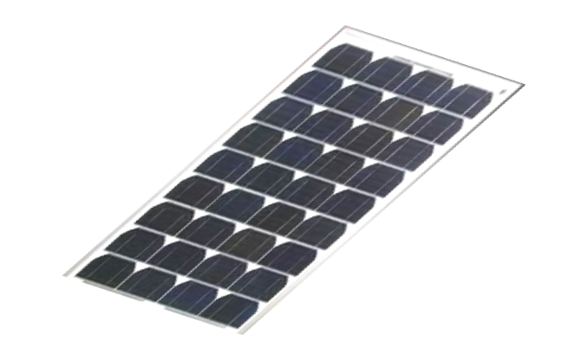

**А**

**V**



̶

+

̶

+



Рис. 3.

3.1. Remove the data for the construction of current-voltage properties in series connection. The results of measurements should be recorded in the table:

Table 1



3.2 Carrying out an experiment for parallel joining of solar cells.  
3.3 Assemble the circuit for parallel connection of the elements according to figure 4:

**А**

**V**



̶

+



+

̶

Рис. 4.

3.4 Remove the data for the construction of current-voltage properties with parallel connection. The results of measurements should be recorded in the table:

Table 2

4. Comparative analysis of connection methods and conclusions on the results of the performance of laboratory work  
In the general coordinate system, construct the current-voltage characteristics for a serial and parallel connection and draw conclusions.  
5.Report writing  
The report on this laboratory work should contain:  
1.Name of the work and its purpose.  
2.The diagrams in Fig. 1 and Fig. 2.  
3. IV characteristics of solar cells for sequential and parallel connection of elements.  
4. Conclusions.

**Control questions**  
  
1. What is solar radiation and how is it used on Earth?  
2. Characteristics of the work of solar cells.  
3. What is the difference between a serial connection of solar panels and a parallel one?  
4. For what purpose does this or that connection scheme apply?  
5. Describe the advantages and disadvantages of the successive connection of solar panels.  
6. Advantages and disadvantages of the sequential connection of solar cells.